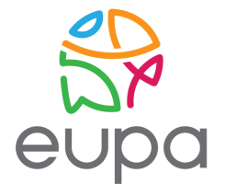

Training on capacity building in the implementation of VET (KA1) Erasmus+ projects

Malta 25-27 April 2017

Application from

First name:

Last name:

Gender:

Date of birth:

Country of residence:

Contact details

Email:
Phone:
Address:

Organisation

Describe briefly your organisation
Describe shortly your role within the organisation

Experience
Describe your experience in the VET sector. Describe any contribution you have made or intend to make in the VET KA1 projects
Describe any successful Erasmus+ project that you have hosted or participated in.

Motivation
What is your motivation to attend this seminar?
What are your expectations of this seminar?

Special Requirements/Other Information
Are you able to work in English?
Do you have any special needs or requirements that the host National Agency should know about (e.g. medical needs, allergies, dietary restrictions, etc.)?
Specify any food requirements that you have (vegetarian, vegan, halal, kosher, etc.)

Disclaimer and Agreements
Please take note of the following conditions that will apply if you are selected to take part in the seminar.

- I confirm that I am 18 years old or older

- I commit myself to participate in the whole process, including:
• to prepare myself carefully for the training course and to do all remote preparation work the team will ask for;
• to take part in the full duration of the training course;
• to participate in the whole evaluation process

- I am aware that obtaining a health and a full travel insurance are my own responsibility and at my own expenses. I understand that the information I provided on my special needs does not remove my own personal responsibility for ensuring my own health.

- I authorise my National Agency and the European Commission to publish, in whatever form and by whatever medium, including the Internet, my correspondence address, information about my organisation and work and pictures taken at the training course.

